God’s kingdom is precious
Reading: Matthew 13:44-45
God’s kingdom is like a treasure hidden in a field. One day a man found the treasure. He hid it again and was so happy that he went and sold everything he owned and bought the field.
Also, God’s kingdom is like a merchant looking for fine pearls. One day he found a very fine pearl. He went and sold everything he had to buy it.

Thought about the reading
The reading today includes two more stories that Jesus told to help us understand what the kingdom of God is like.
The first story is about a man who found treasure in a field. In those days, the treasure belonged to the person who owned the field. The man was so happy to find the treasure that he sold everything he had so that he could buy the field and the treasure would be his.
In the second story, a man found a beautiful pearl and he sold everything so he could buy it.
These stories tell us that God’s kingdom is the most precious thing in the world. It is worth giving everything we have to be part of it.

Prayer
Lord Jesus, thank you that your kingdom is so precious. It is worth more than anything else in the world.
Please help me to be willing to give everything I have and my whole life to you, so that I can be part of your kingdom.
Amen

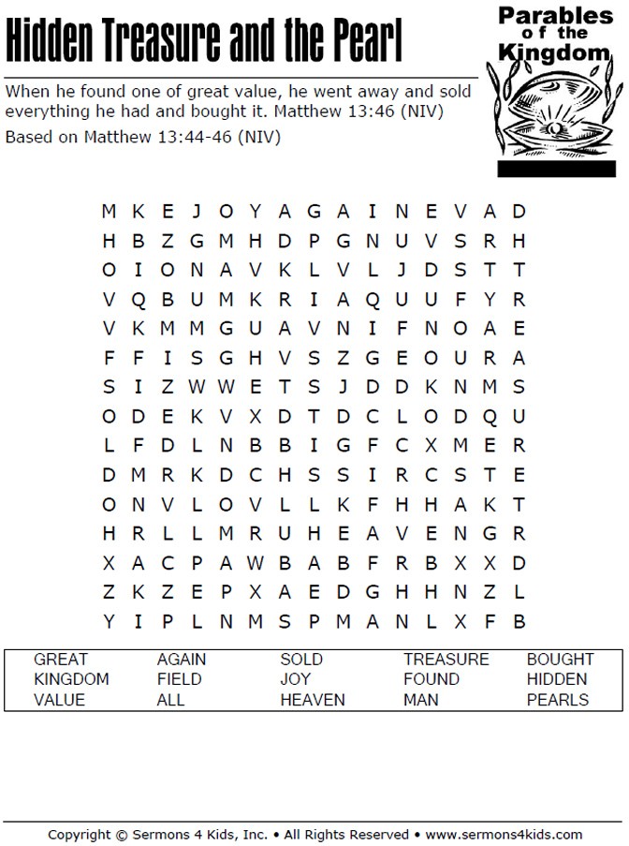

Cambridge Causeway

Spring 2023
Bible Study notes

The Kingdom of God
4. God’s kingdom is precious
By Chrissy Cole

